Name:____________________________
CMIS 310
HOMEWORK #5 – Week #5

This homework is worth 10% of your course grade.

Read each problem carefully. Failure to follow the instructions for a problem will result in a zero score for that problem.

Submit the completed Homework via Assignment in LEO.

- Do Exercise 2 in Chapter 6 (Memory) of Null and Lobur
Suppose a computer using direct mapped cache has 2³² words of main memory and a cache of 1024 blocks, where each cache block contains 32 words.
  - How many blocks of main memory are there?
  - What is the format of a memory address as seen by the cache, that is, what are the sizes of the tag, block, and word fields?
  - To which cache block will the memory reference 000063FA₁₆ map?

- Do Exercise 4 in Chapter 6 (Memory) of Null and Lobur
Suppose a computer using fully associative cache has 2²⁴ words of main memory and a cache of 128 blocks, where each cache block contains 64 words.
  - How many blocks of main memory are there?
  - What is the format of a memory address as seen by the cache, that is, what are the sizes of the tag and word fields?
  - To which cache block will the memory reference 01D872₁₆ map?

- Do Exercise 6 in Chapter 6 (Memory) of Null and Lobur
A 2-way set associative cache consists of four sets. Main memory contains 2K blocks of eight words each.
  - Show the main memory address format that allows us to map addresses from main memory to cache. Be sure to include the fields as well as their sizes.
  - Compute the hit ratio for a program that loops 3 times from locations 8 to 51 in main memory. You may leave the hit ratio in terms of a fraction.

- Do Exercise 8 in Chapter 6 (Memory) of Null and Lobur
Suppose a computer using set associative cache has 2²¹ words of main memory and a cache of 64 blocks, where each cache block contains 4 words.
  - If this cache is 2-way set associative, what is the format of a memory address as seen by the cache, that is, what are the sizes of the tag, set, and word fields?
  - If this cache is 4-way set associative, what is the format of a memory address as seen by the cache?

- Do Exercise 12 in Chapter 6 (Memory) of Null and Lobur
Suppose a process page table contains the entries shown below. Using the format shown in Figure 6.15a, indicate where the process pages are located in memory.
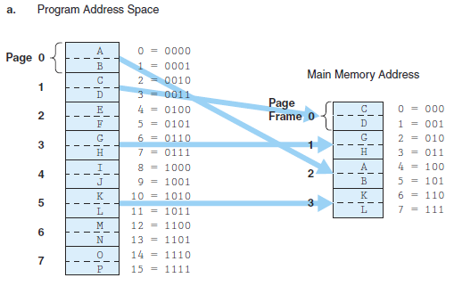

Frame | Valid bit
1 | 1
- | 0
0 | 1
3 | 1
- | 0
- | 0
2 | 1
- | 0

Figure 6.15a
The text of exercises and similar solved exercises are on the topic Books24x7 Readings:
http://library.books24x7.com.ezproxy.umuc.edu/assetviewer.aspx?site=VGX8U&bookid=5893&chunkid=188441613

